**Case Study**

**Name: Priyeshwar**

**Mail:** [**priyesh2664@gmail.com**](mailto:priyesh2664@gmail.com)

**Load CSV file**

Create a pandas DataFrame from the dataset for easier processing and visualization. Replace the file path below with your actual file location.

**import numpy as np**

**import pandas as pd**

**df = spark.table('hive_metastore.default.employees').toPandas()**

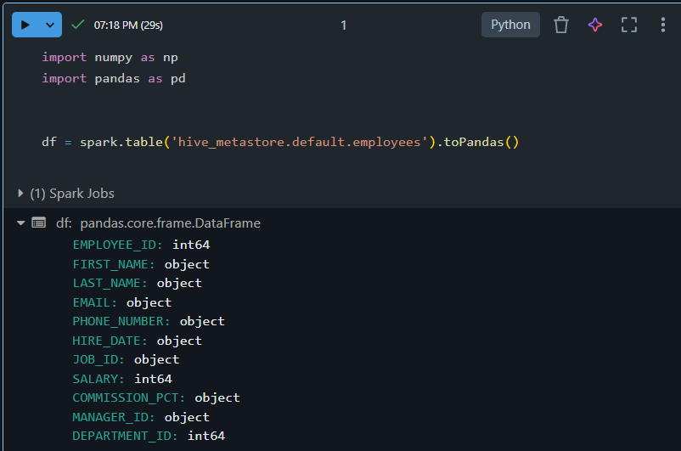

**Use pandas for data insights**

**Check shape of the DataFrame**

**df.shape**

The df.shape command returns the number of rows and columns.

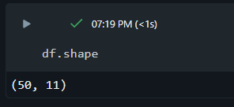

**Generate descriptive statistics**

**df.describe()**

The df.describe() command provides numerical summaries such as mean, standard deviation, min, max, and percentiles.

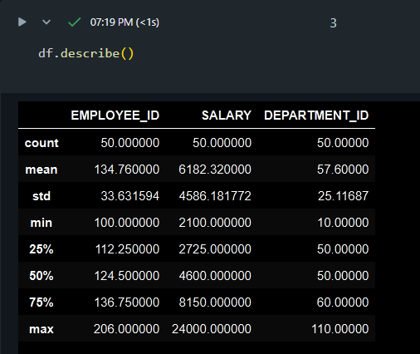

**Generate a data profile**

display(df)

This displays a full interactive table of the data for profiling.

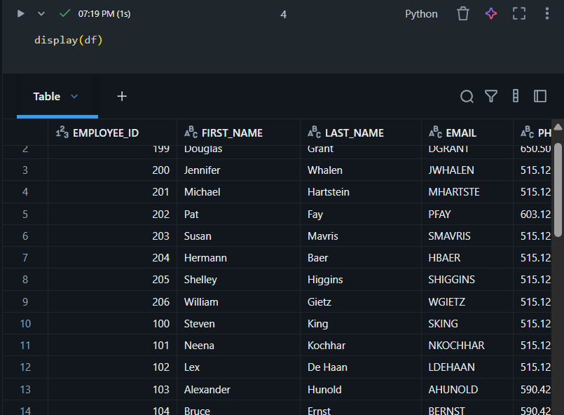

**Clean the data**

**Remove duplicate data**

duplicate_rows = df.duplicated().sum()

duplicate_columns = df.columns[df.columns.duplicated()].tolist()

print("Duplicate rows count:", duplicate_rows)

print("Duplicate columns:", duplicate_columns)

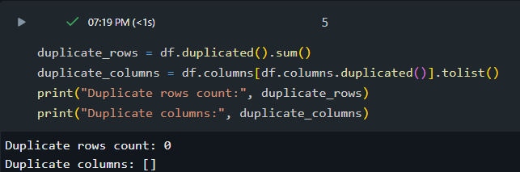

**Handle null or missing values**

df = df.replace('-', np.nan)

df = df.fillna(0)

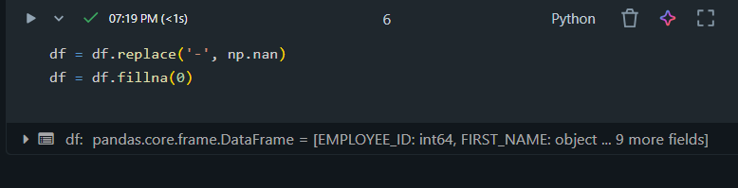

**Reformat dates**

df['HIRE_DATE'] = pd.to_datetime(df['HIRE_DATE'], format='%d-%b-%y', errors='coerce')

display(df)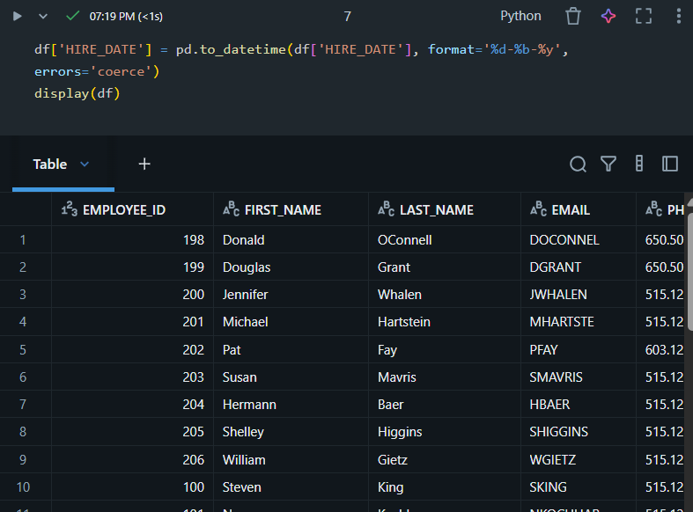

**Filter for specific conditions**

# Employees with salary > 5000

high_salary = df[df['SALARY'] > 5000]

# Employees in department 20

dept_20 = df[df['DEPARTMENT_ID'] == 20]

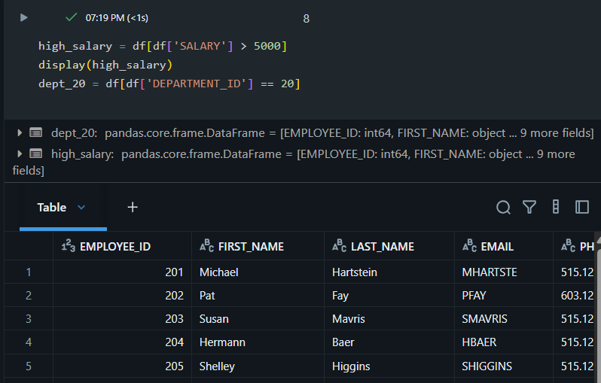

**Create visualizations using the dataset**

**Line Chart**

df.sort_values('HIRE_DATE').plot(x='HIRE_DATE', y='SALARY', kind='line', title='Salary Trend Over Time')

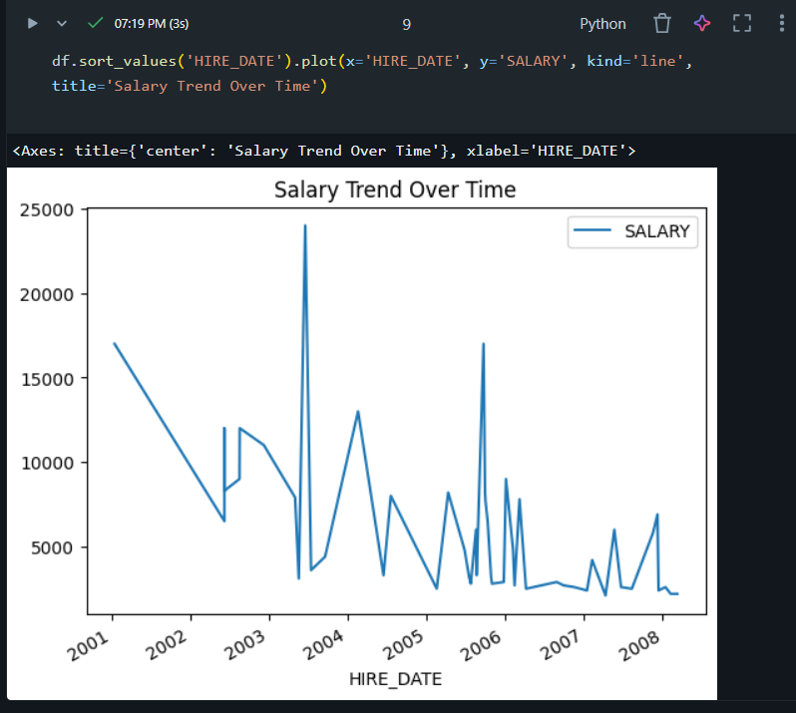

**Area Chart**

df.groupby('DEPARTMENT_ID')['SALARY'].sum().plot(kind='area', title='Total Salary by Department')

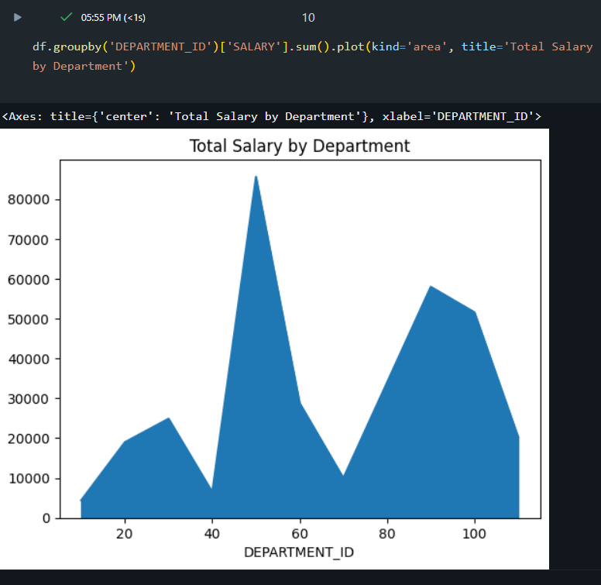

**Delta Table Operations**

**Create a Delta Table**

# Convert pandas DataFrame to Spark DataFrame

spark_df = spark.createDataFrame(df)

# Write as Delta table

spark_df.write.format("delta").mode("overwrite").saveAsTable("hive_metastore.default.employee_delta")

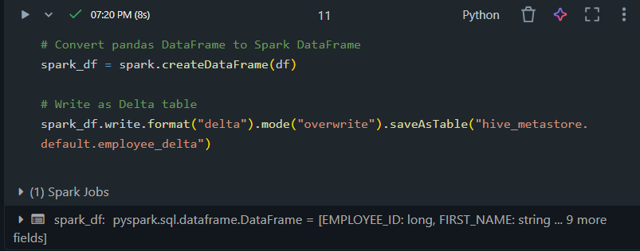

**Merge & Upsert to a Delta Table**

from delta.tables import DeltaTable

from pyspark.sql.types import StructType, StructField, IntegerType, StringType, DoubleType, DateType

from datetime import datetime

# Define schema explicitly

schema = StructType([

    StructField("EMPLOYEE_ID", IntegerType(), False),

    StructField("FIRST_NAME", StringType(), True),

    StructField("LAST_NAME", StringType(), True),

    StructField("EMAIL", StringType(), True),

    StructField("PHONE_NUMBER", StringType(), True),

    StructField("HIRE_DATE", DateType(), True),

    StructField("JOB_ID", StringType(), True),

    StructField("SALARY", DoubleType(), True),

    StructField("COMMISSION_PCT", DoubleType(), True),

    StructField("MANAGER_ID", IntegerType(), True),

    StructField("DEPARTMENT_ID", IntegerType(), True)

])

# Create source DataFrame with explicit schema

source = spark.createDataFrame([

    (205, "Alex", "Smith", "ASMITH", "650.123.9999", datetime.strptime("12-Jan-09", "%d-%b-%y"), "IT_PROG", 9000.0, None, 101, 60)

], schema=schema)

# Merge into Delta table

target = DeltaTable.forName(spark, "hive_metastore.default.employee_delta")

(

    target.alias("t")

    .merge(source.alias("s"), "t.EMPLOYEE_ID = s.EMPLOYEE_ID")

    .whenMatchedUpdateAll()

    .whenNotMatchedInsertAll()

    .execute()

)

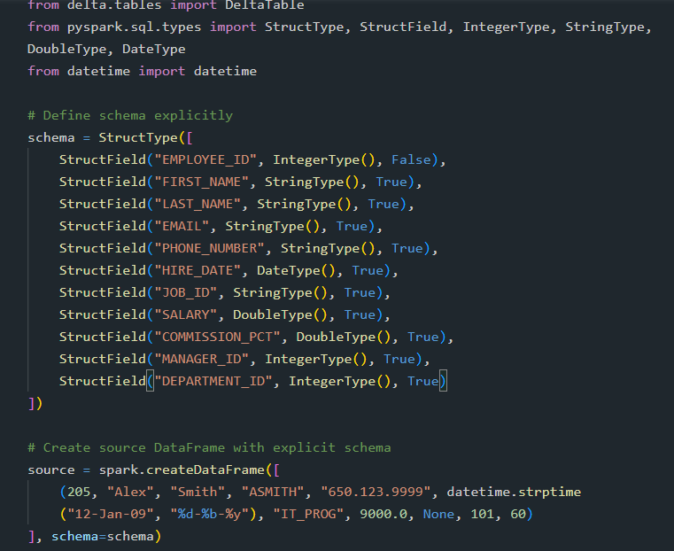

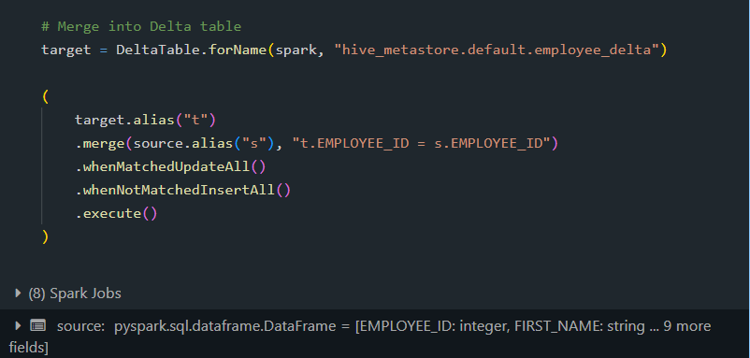

**Read a Delta Table**

df_delta = spark.read.format("delta").table("hive_metastore.default.employee_delta")

display(df_delta)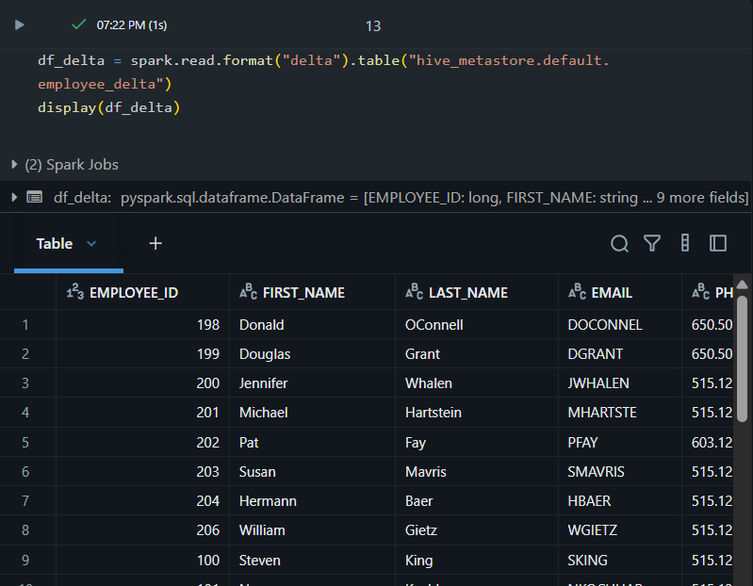

**Write to a Delta Table**

spark_df.write.format("delta").mode("append").saveAsTable("hive_metastore.default.employee_delta")

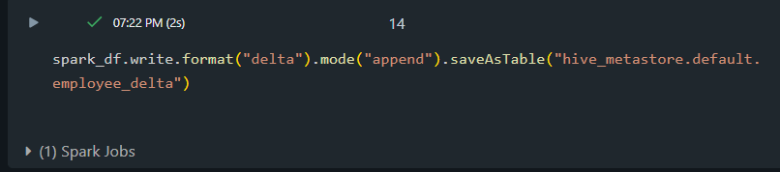

**Update a Delta Table**

target.update(

condition="DEPARTMENT_ID = 50",

set={"SALARY": "SALARY + 500"}

)

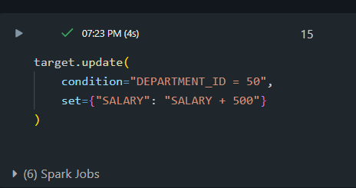

**Display Table History**

display(spark.sql("DESCRIBE HISTORY hive_metastore.default.employee_delta"))

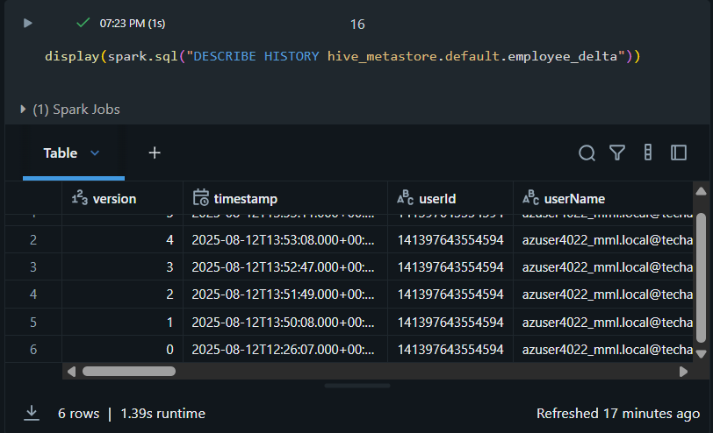

**Query Earlier Version (Time Travel)**

df_old = spark.read.format("delta").option("versionAsOf", 0).table("hive_metastore.default.employee_delta")

display(df_old)

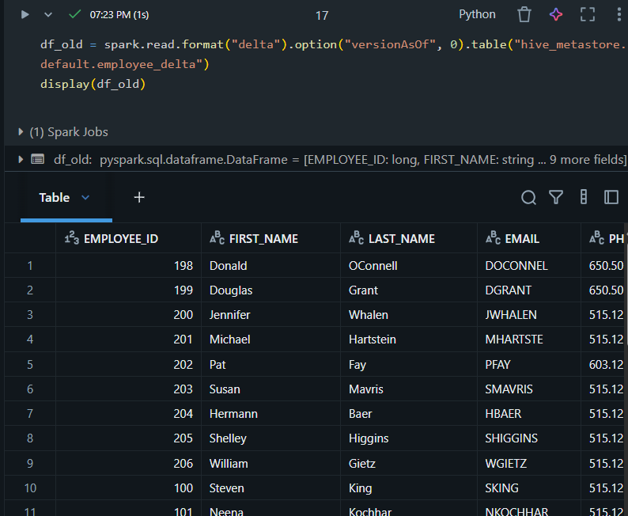

**Optimize a Delta Table**

spark.sql("OPTIMIZE hive_metastore.default.employee_delta")

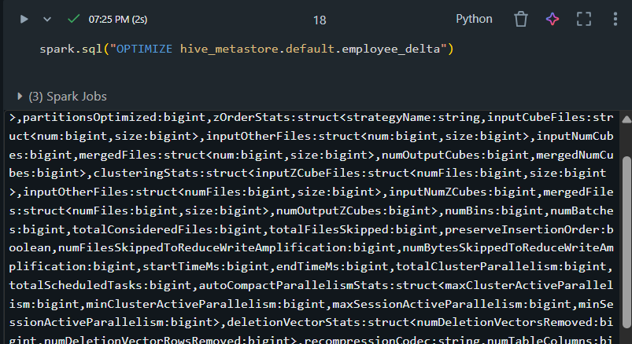

**Clean Up Snapshots with VACUUM**

spark.sql("VACUUM hive_metastore.default.employee_delta RETAIN 168 HOURS")

